
Student Name :_____________________

Short Exam related to Linear Algebra – Computer Vision 2024

1 h – No document allowed except lecture slides

Part 1: Recording an image with a camera adds distortion to a scene, i.e. distances, angles, and areas are different (affine distortion) as well as parallelism is not preserved (perspective distortion).

Question 1 (2 points): Construct the vanishing line(s) in the two figures below geometrically (by hand).

Ans





Question 2 (1 point): True or False? The number of vanishing points can be higher than three for 3D objects not defined by a parallelepiped shape (such as the ones illustrated below)?
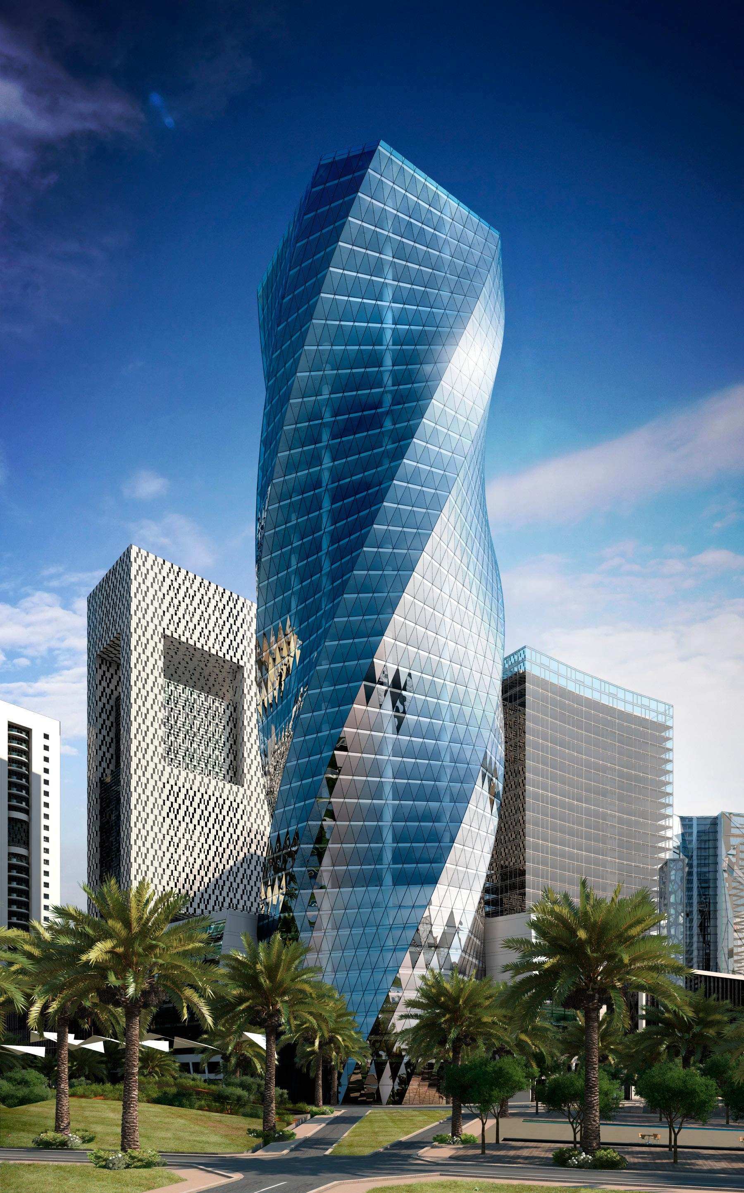

Ans : True

Part 2: Determining unknown transformations

Question 3 (3 points): Suppose we have two triangles: ABC and DEF. What type of transformation will map A to D, B to E, and C to F?

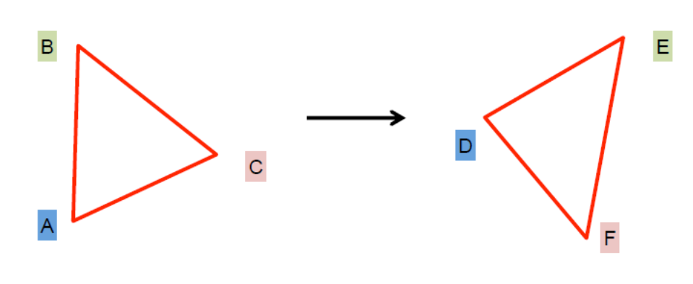

Ans:
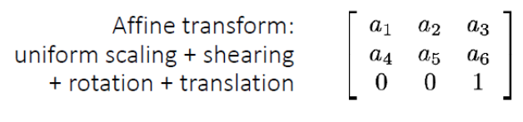
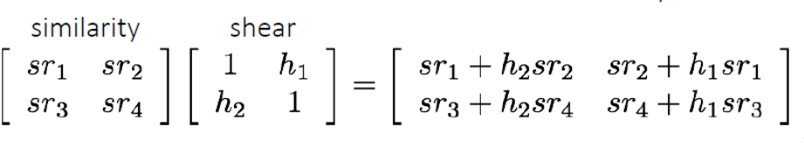

Question 4 (1 point): How many degrees of freedom do we have?
Ans: 6. Affine transformations are combinations of arbitrary (4 DOF) linear transformations; and translations (2 DOF)

Part 3: Determining unknown shape after known transformations
Here is a test pattern in 2D:
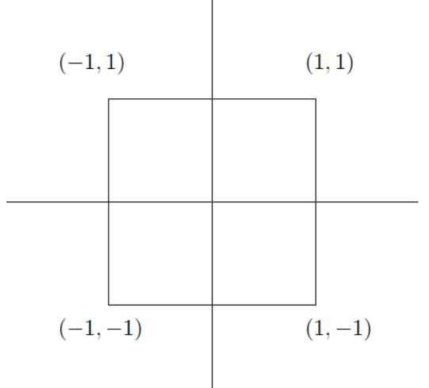

Question 4 (3 points): Draw the image of this test pattern after being transformed by each of the following (individually, not cumulatively). Which type of transformation corresponds to each of these matrices?
(i)
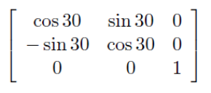
(ii)
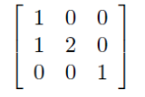
(iii)
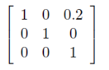
Ans
(i) rotation
(ii) Affine

(iii) Translation
Question 5 (3 points): Determine whether the below properties are true/false?
Transformation (i) : Origin will be mapped to origin
Lines will be mapped to lines
Parallel lines will not remain parallel
Ratios (along any line) will be preserved
Ans: “Lines will be mapped to lines” true for affine transformations, “Parallel lines will not remain parallel” false for rotation transformations. “Ratios (along any line) will be preserved” true for affine transformations.

Transformation (ii) : Origin will be mapped to origin
Lines will be mapped to lines
Parallel lines will not remain parallel
Ratios (along any line) will be preserved

Ans: “Lines will be mapped to lines” true for affine transformations, “Parallel lines will not remain parallel” false for translation transformations. “Ratios (along any line) will be preserved” true for affine transformations

Transformation (iii) : Origin will be mapped to origin
Lines will be mapped to lines
Parallel lines will not remain parallel
Ratios (along any line) will be preserved

Ans: “Lines will be mapped to lines” true for affine transformations, “Origin will be mapped to origin” false for a translation, “Parallel lines will not remain parallel” false for translation transformations. “Ratios (along any line) will be preserved” true for affine transformations.

Question 6 (6 points): In this question, we are again working in 2 dimensions. All transformations map from the standard Cartesian frame to the standard Cartesian frame. Let R(θ) be the matrix for a rotation about the origin of θ in the counter-clockwise direction. Let T( v ) be the matrix for a translation by vector v. Let S(s_{x}; s_{y}) be the matrix for a non-uniform scale about the origin by an amount s_{x} in the x direction and s_{y} in the y direction.
Given a point p, two perpendicular unit vectors v and w, and two scale factors a and b, suppose we want to perform a non-uniform scale about p by a in direction v and b in direction w. Give the appropriate matrix product to achieve this transformation using the above notation for the matrices.

Note: You should give expanded forms of the matrices; your matrix product should be products of R(), T(), and S() (each operation may be used more than once). Also, these should be treated as matrices and not transformations (which is important for the order).

Ans
p’’’
*

p *

w
* v

Step 1: T( oo’ ) translation of origins from the world coordinate frame to the output coordinate frame defined by the vectors v and w. p’ = T( oo’ ) p.

Step 2: R(θ) rotation of the world coordinate frame. P’’ = R(θ) p’.

Step 3 : S(a, b) scaling P’’’ = S(a, b) p’’.

Step 4 : Apply the inverse rotation R(θ) and the inverse translation T( oo’ ) to come back to the world coordinate frame.

Using homogeneous coordinates we have for steps 1 to 3: P’’’ = S(a, b) R(θ)T( oo’ ) p

a 0 0 Cos θ -Sin θ 0 1 0 Tx
0 b 0 Sin θ Cos θ 0 0 1 Ty
0 0 1 0 0 1 0 0 1

a 0 0 Cos θ -Sin θ Tx Cos θ - Ty Sin θ
0 b 0 Sin θ Cos θ Tx Sin θ + Ty Cos θ
0 0 1 0 0 1

a Cos θ - a Sin θ a (Tx Cos θ - Ty Sin θ)
b Sin θ b Cos θ b (Tx Sin θ + Ty Cos θ)
0 0 1

Final transformation with all steps: T( o’o ) R(-θ) S(a, b) R(θ) T( oo’ ) p

Part 4: Determining unknown transformations

Question 7 (4 points): What type of transformation was applied to the following images?

(i) Step 1: p’ is the world coordinate of p after transformation

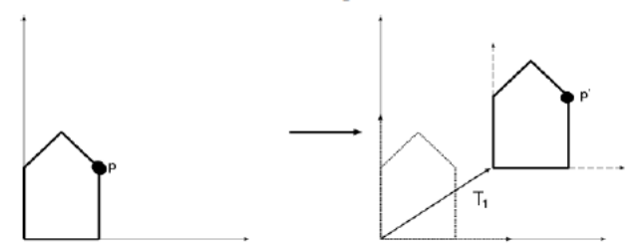

(ii) Step 2: p’’ is the world coordinate of p’ after transformation
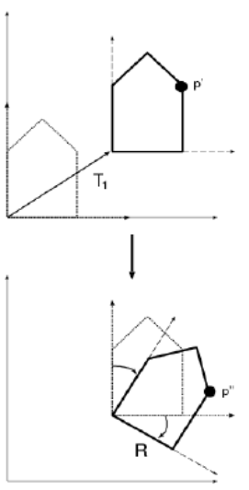
(iii) Step 3: p’’’ is the world coordinate of p’ after transformation

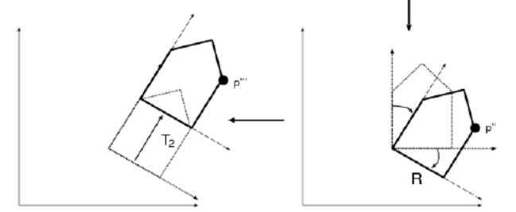

(iv) 3 consecutive transformations: p’’’ is the world coordinate of p after all transformations
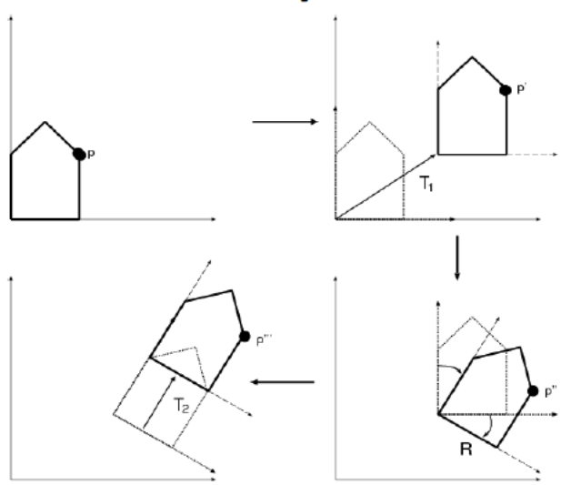

Ans:
P’ = T₁ p (that corresponds to a translation of the origin from o to o’ of the 2D frame)
P’’ = R p’ = R T₁ p (that corresponds to a rotation of the 2D frame around the origin o’)
P’’’ = T₂ p ‘’ = T₂ R T₁ p (that corresponds to a second translation of the origin from o’ to o’’ of the 2D frame).
P’’’ corresponds to local coordinates defined relatively to the last 2D frame.

Question 8 (2 points): What set of transformations was applied to the following images (from origin) ?

Y’’
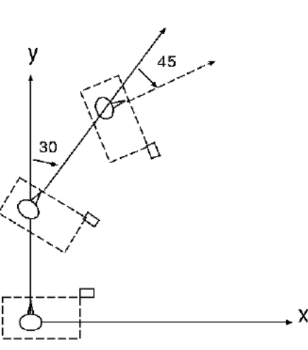
5

0
0
5

Ans :

Step 1: translation along the Y dimension (XY -> X’Y’) (that corresponds to a translation of the origin of the 2D frame XY from (0, 0) to (0, 5) along the Y dimension, ie Y and Y’ are aligned).
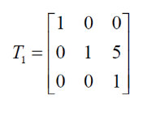
Step 2: right rotation of 30 degrees (X’Y’ -> X’’Y’’) (that corresponds to a rotation around the origin (0, 0) of the 2D frame X’Y’).
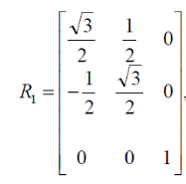
Step 3: translation along the Y’’ dimension (same as for step 1) (X’’Y’’ -> X’’’Y’’’) (that corresponds to a translation of the origin of the 2D frame X’’Y’’ from (0, 0) to (0, 5) along the Y’’ dimension, ie Y’’ and Y’’’ are aligned).
Step 4: right rotation of 45 degrees (X’’’Y’’’ -> X’’’’Y’’’’) (that corresponds to a rotation around the origin (0, 0) of the 2D frame X’’’Y’’’).
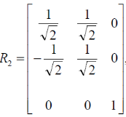

So, we have this sequence of transformations: R2 T1 R1 T1

If we consider a point p in the world coordinate frame then p’’’’ corresponds to local coordinates defined relatively to the 2D frame X’’’’Y’’’’. If we want to define the coordinate of p’’’’ in the world coordinate frame we have to consider the inverse process (change of origins), ie T1 R1 T1 R2.

Exercise from 16385 Computer Vision Spring 2018, Lecture 7, http://www.cs.cmu.edu/~16385/
The object drawn first moved 5m forward, next turned 30 degrees to right, moved 5m forward again, and turned 45 degrees to the right, and stopped.

